Salesforce Project: FitTrack – Health & Fitness CRM
Industry: Fitness & Health
Project Type: B2C Salesforce CRM Implementation
Target Users: Gym Admin, Trainers, Members
Problem Statement:
Most gyms manage members, trainers, and workout plans manually using spreadsheets or paper records. This results in:
- Difficulty tracking active/expired memberships
- Inefficient trainer assignment
- Delayed communication with members
- Poor reporting for management
FitTrack Solution:
A Salesforce-based Health & Fitness CRM to automate member management, trainer assignment, workout plans, reporting, and notifications.

Phase 1: Problem Understanding & Industry Analysis
1. Requirement Gathering:
- Member management (Name, Email, Phone, Membership dates, Fitness goals)
- Trainer management (Name, Expertise, Assigned Members)
- Workout plan management (Name, Duration, Intensity, Assigned Member)
- Dashboard and reporting (Active vs Expired members, Trainer workload)
- Automated notifications for membership expiry or workout plan updates
2. Stakeholder Analysis:
- Admin: Full control over members, trainers, and dashboard monitoring
- Trainer: Track assigned members, update workout plans, receive notifications
- Receptionist (optional): Add new members, manage basic member data
- Member: View personal membership and progress (optional, external portal possible)
3. Business Process Mapping:
- Member signs up → added to CRM
- Assign membership start/end dates → track membership status
- Assign trainer to member → create workout plan
- Daily/weekly updates on workouts → progress tracking
- Generate reports → dashboards for active/expired members
4. Use Case Analysis:
- Manual tracking leads to errors, missed follow-ups, and unoptimized trainer workload
- Management cannot see real-time member progress or trainer efficiency
5. AppExchange Exploration:
- Checked apps like MyFitnessPal for Salesforce and Health Cloud Lite for reference features

Phase 2: Org Setup & Configuration
Purpose: Configure Salesforce org for FitTrack to ensure users, profiles, roles, and security settings are correct.
Steps:
- Salesforce Edition: Developer Edition
- Company Profile Setup: Name, Address, Timezone, Locale, Currency
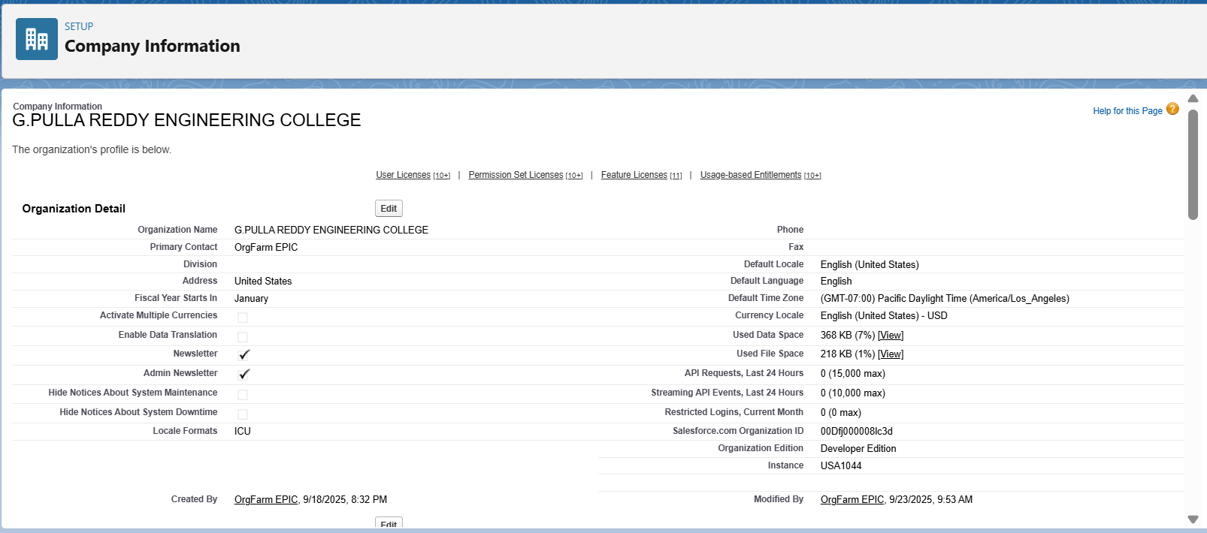

- Business Hours & Holidays: Mon–Sun, 6 AM – 10 PM; add public holidays
- Fiscal Year: Standard
- User Setup & Licenses: Create sample users:
  - Admin (Full access)
  - Trainer (Manage Members & Workout Plans)
  - Receptionist (Member creation only)
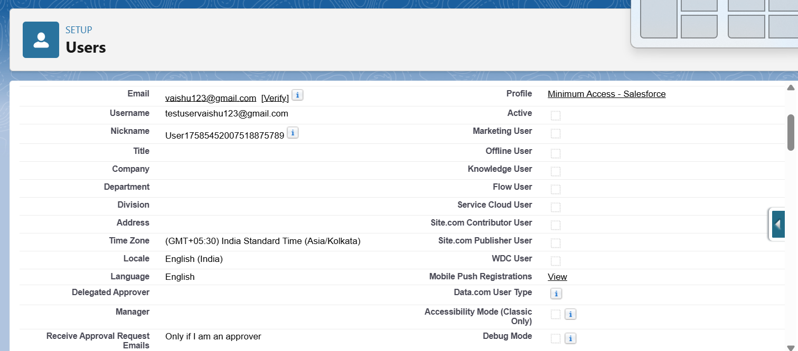
- Profiles:
  - Admin → Full access
  - Trainer → Edit/View Members & Workout Plans
  - Receptionist → Create/View Members only
- Roles: Admin > Trainer > Receptionist
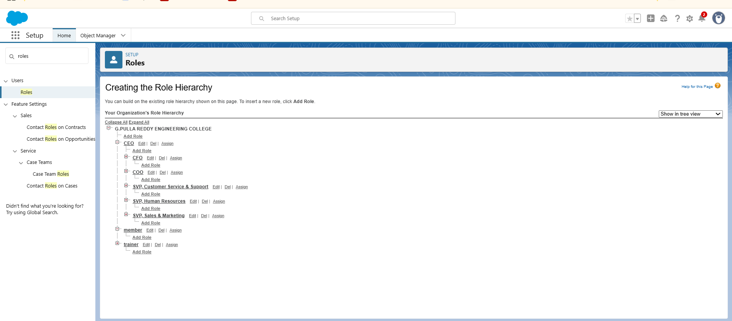
- Permission Sets: Assign dashboard/report access for Trainers
- OWD & Sharing Rules:
  - Members → Private
  - Trainers → Private
  - Workout Plans → Private
  - Sharing rules → Share members with their assigned trainers
- Login Access Policies: Admin can login as any user
- Sandbox Usage & Deployment Basics: Optional for larger org setup

Phase 3: Data Modeling & Relationships
Purpose: Design objects and relationships for member, trainer, and workout data.
Custom Objects:
- Member: Name, Email, Phone, Membership Start/End, Fitness Goal, Age, Gender
- Trainer: Name, Email, Phone, Expertise
- Workout Plan: Plan Name, Duration, Intensity, Assigned Member

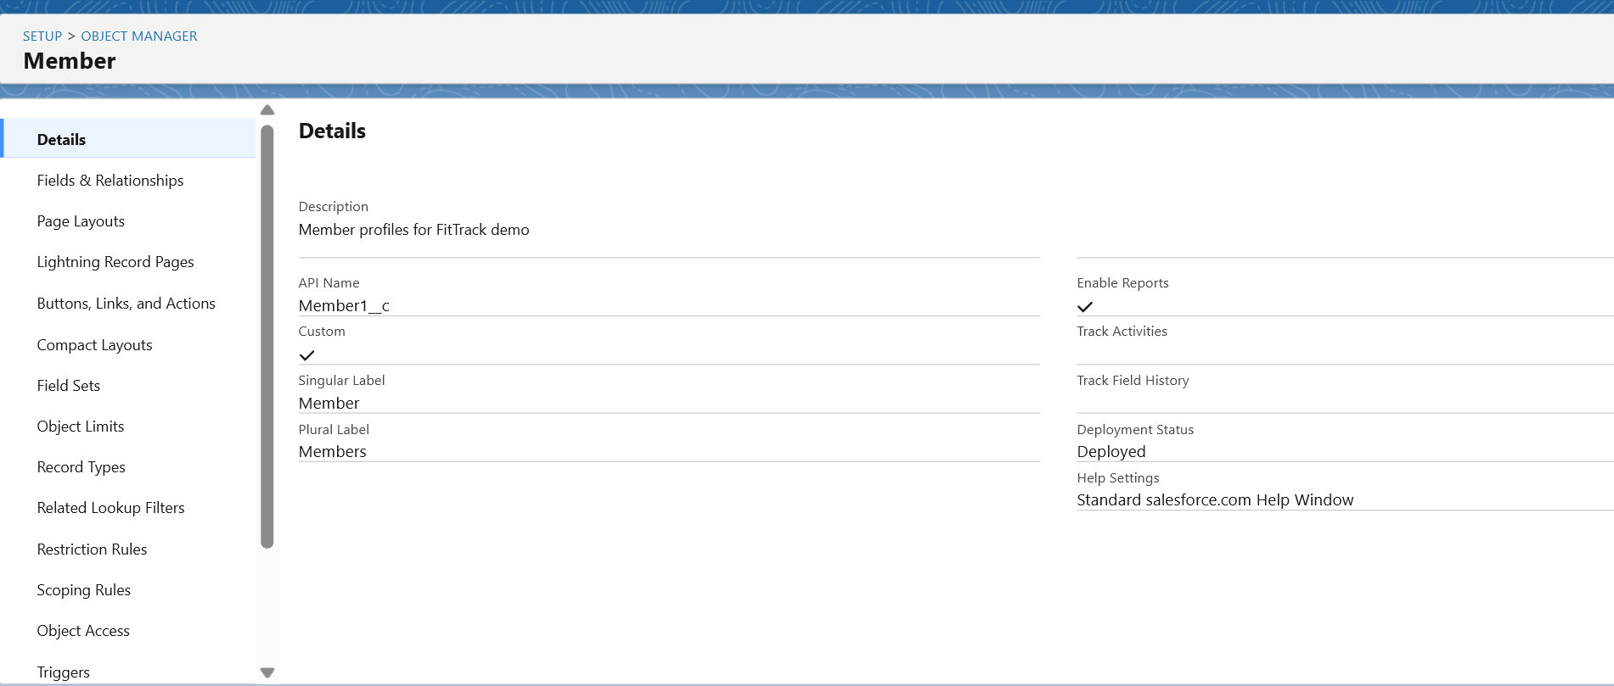

Relationships:
- Member ↔ Trainer → Lookup relationship (each member has a trainer)
- Member ↔ Workout Plan → Master-Detail (one member can have multiple plans)

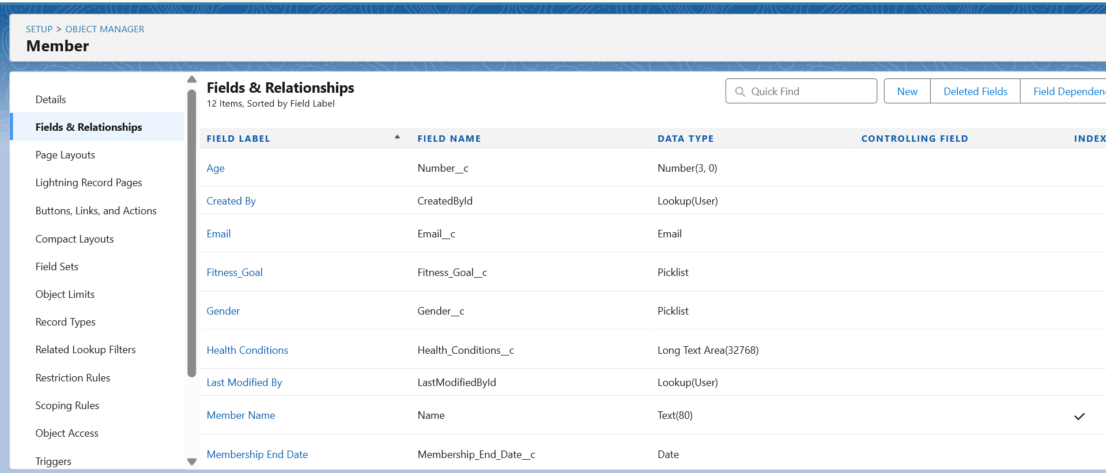
Additional Configuration:
- Page Layouts: Display key fields on Member, Trainer, Workout Plan
- Compact Layouts: Show Name, Membership Status, Fitness Goal
- Schema Builder: Visual diagram of objects and relationships
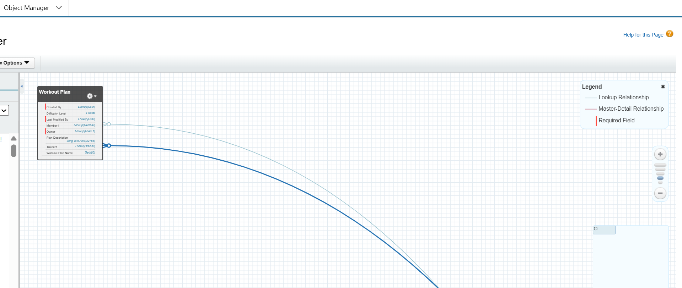

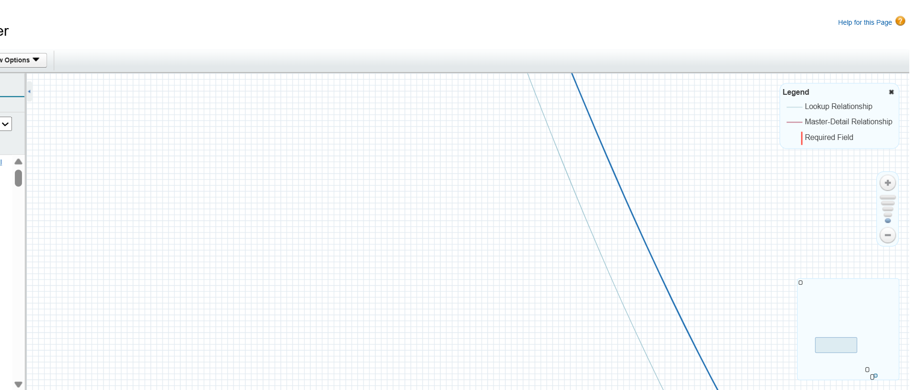

Phase 4: Process Automation (Admin)
Purpose: Automate repetitive tasks and notifications.
Automation Examples:
- Validation Rules: Ensure Membership End Date > Start Date

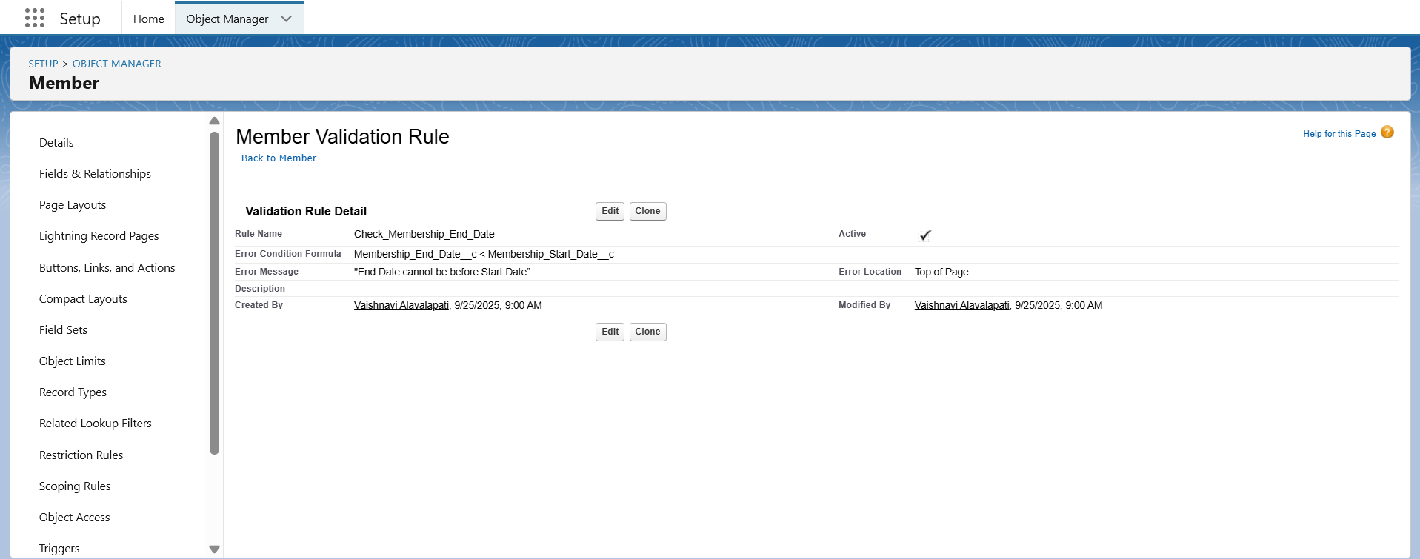
- Workflow / Process Builder:
  - Notify Admin/Trainer when membership is near expiry
  - Auto-assign new members to default trainer if none chosen
- Flow Builder:
  - Auto-create “Expired Members” report
  - Automate follow-up reminders
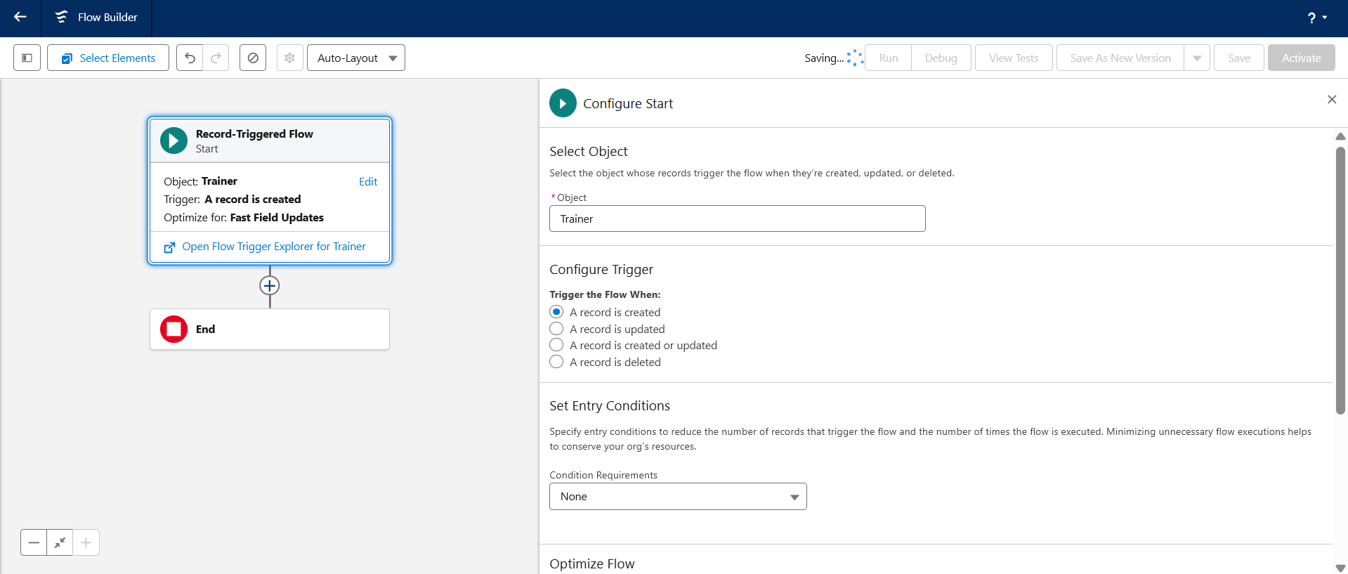
- Email Alerts / Custom Notifications:
  - Notify members of upcoming expiry or trainer updates

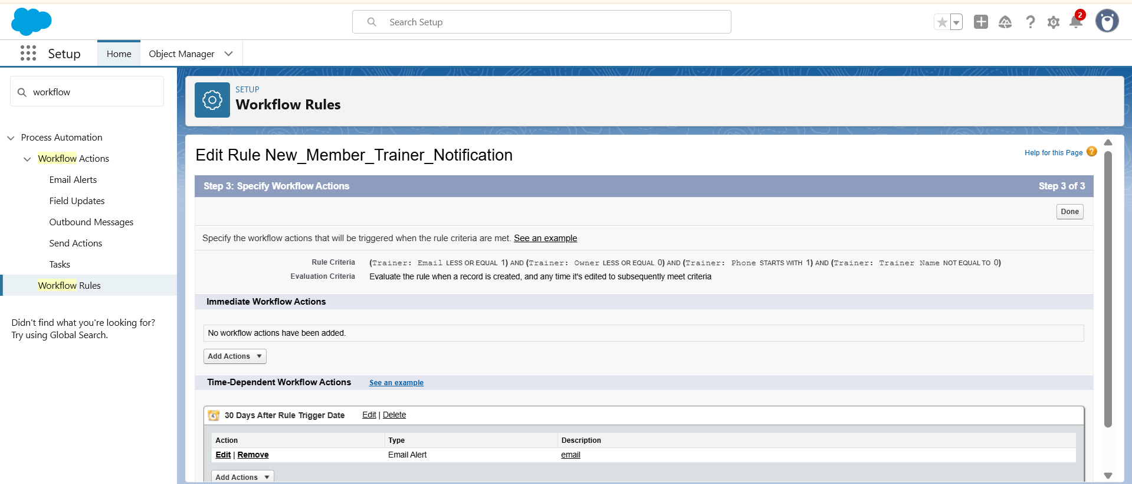

Phase 5: Apex Programming (Developer)
Purpose: Use Apex code for advanced automation beyond clicks.
Examples:
- Triggers:
  - Member Insert → Assign default trainer
  - Workout Plan Update → Notify trainer
- Helper Classes: Calculate membership status (Active/Expired)
- Batch Apex / Queueable Apex: Bulk update expired members
- Test Classes: For triggers and classes to meet Salesforce requirements
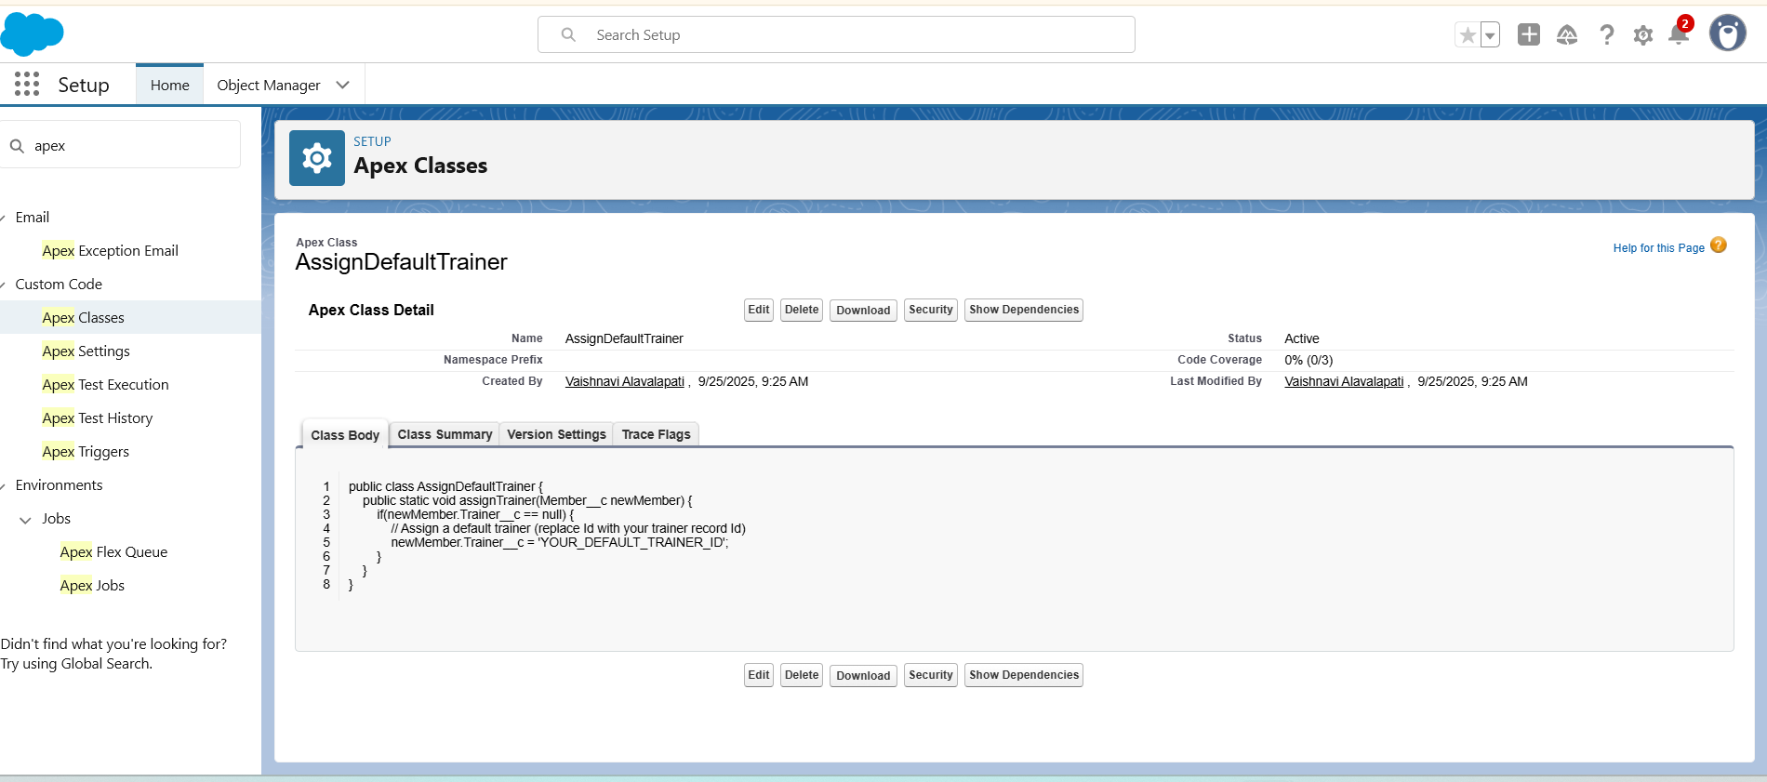

Phase 6: User Interface Development
Purpose: Create a user-friendly experience for different roles.
Steps:
- Create FitTrack App in Lightning App Builder

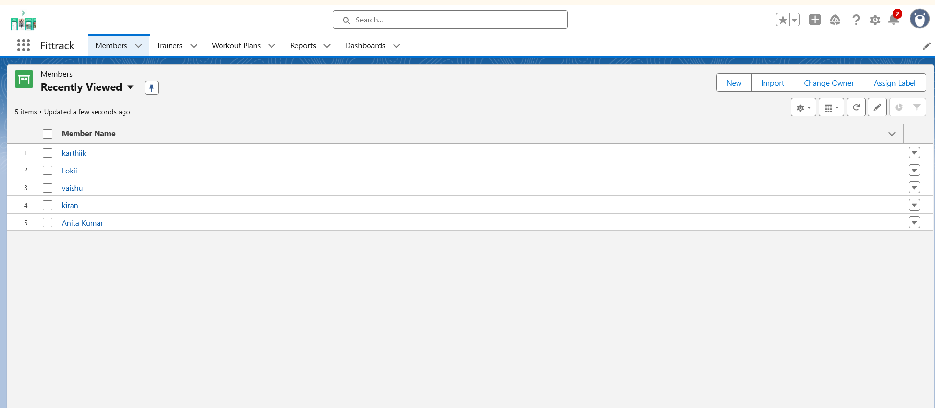
- Add Tabs: Members, Trainers, Workout Plans, Reports, Dashboards
- Customize Record Pages for Members and Workout Plans
- Home Page Layouts: Dashboard showing Active vs Expired Members, Trainer workload
- Optional: Lightning Web Component for member search or fitness progress chart

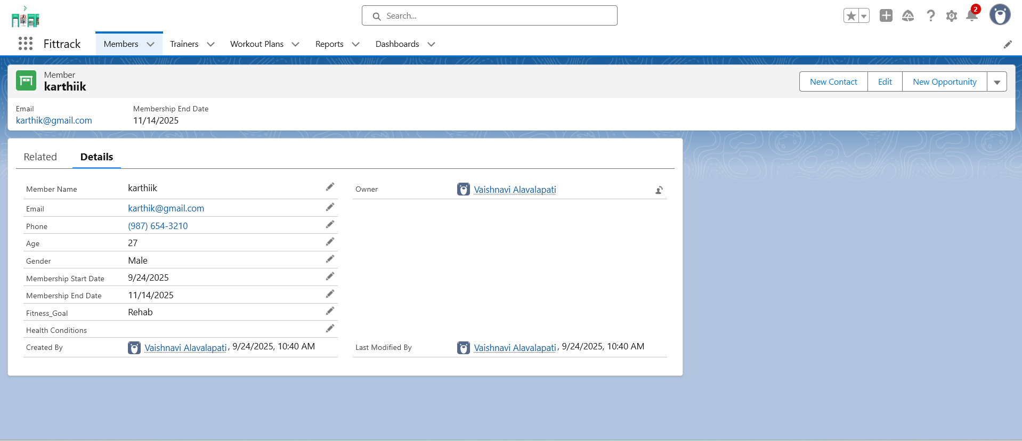
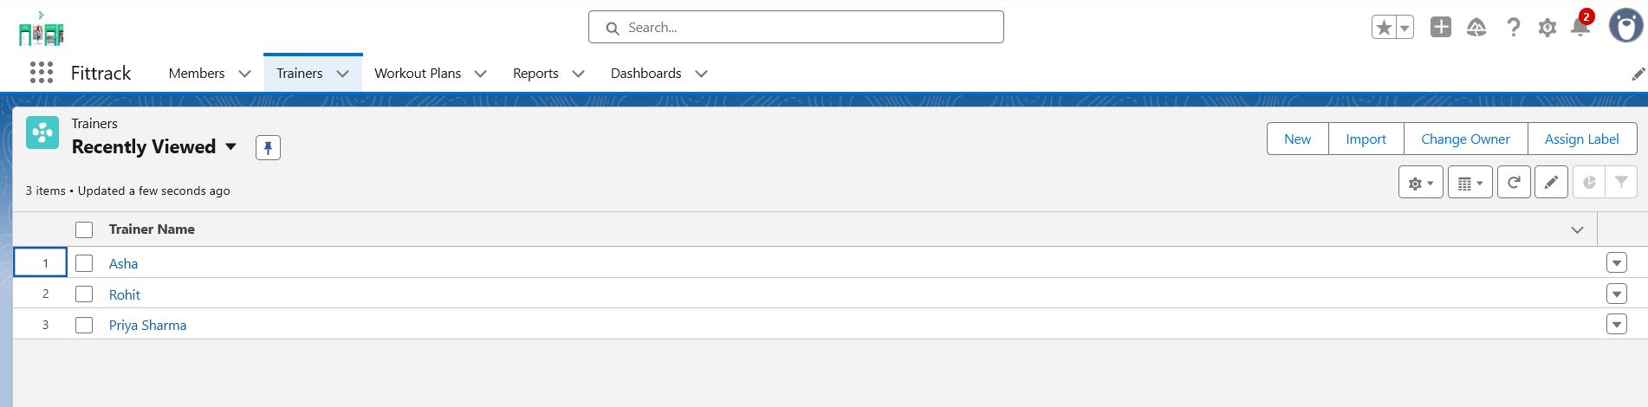
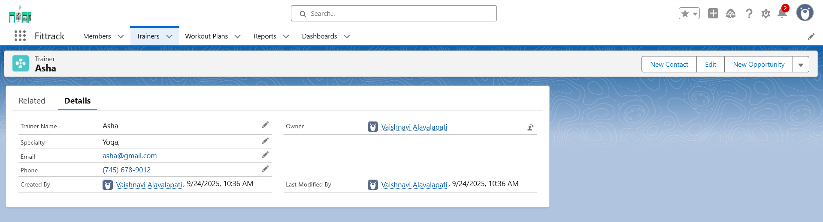
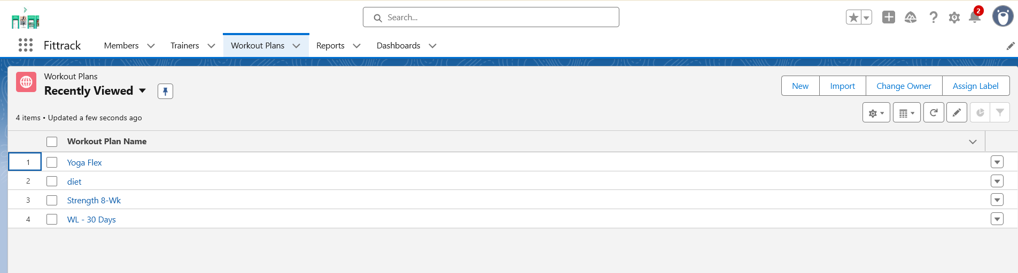
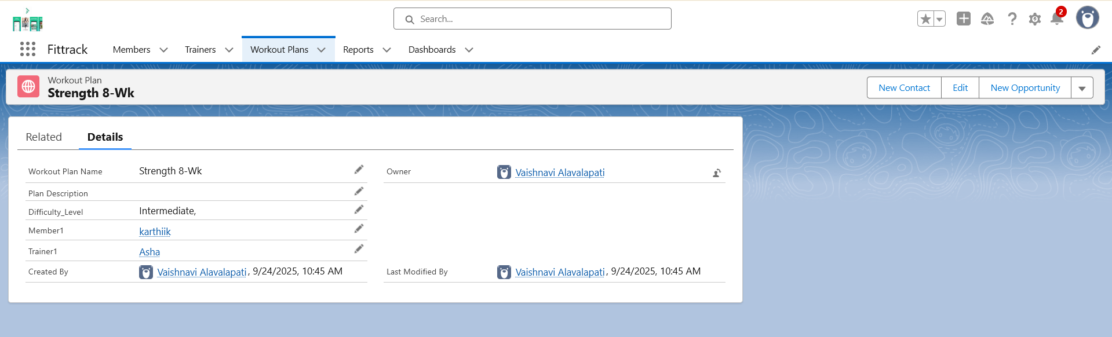

Phase 7: Integration & External Access
Purpose: Connect Salesforce with external systems (optional).
- Named Credentials: Connect with third-party APIs (fitness trackers, email, SMS)

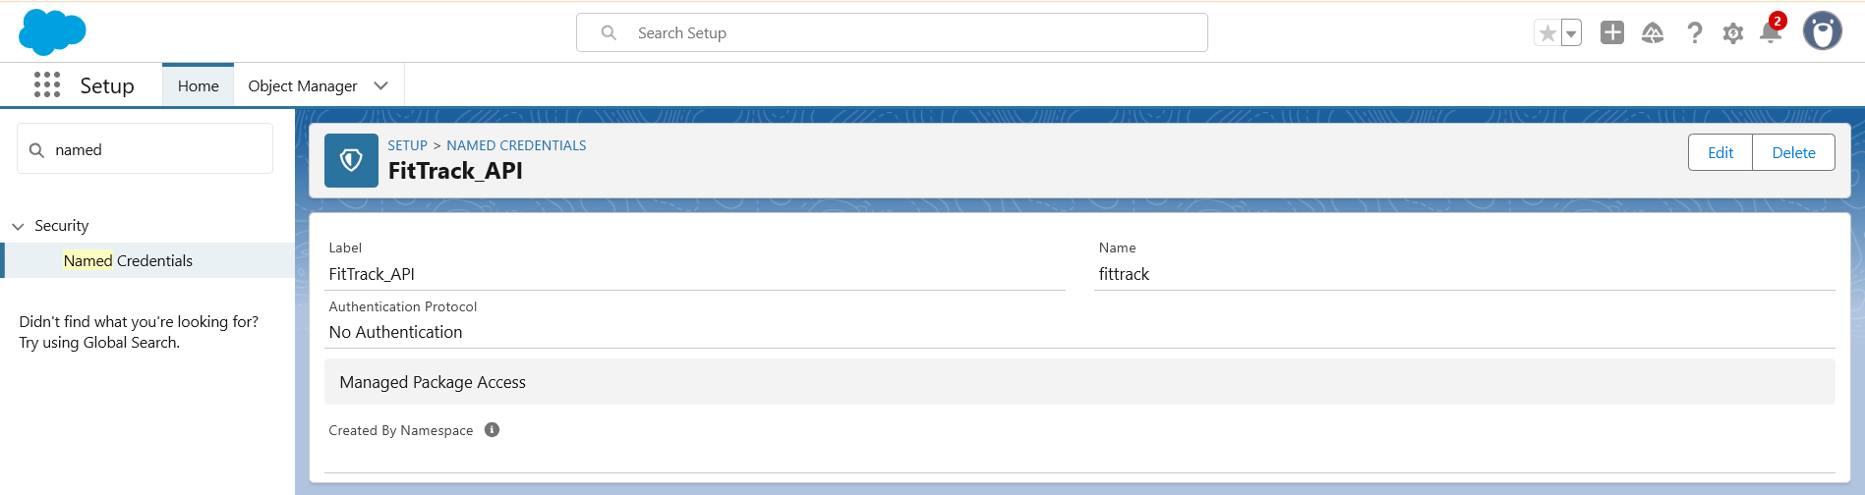
- Platform Events: Notify trainer when workout plan updated
- Remote Site Settings: Allow external API access

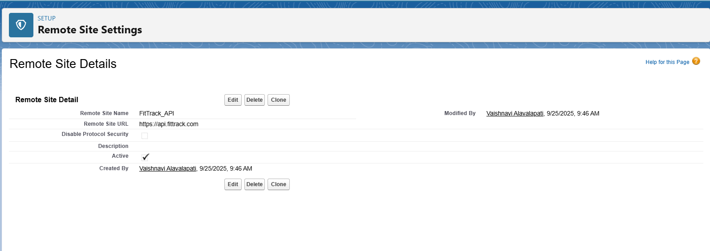

Phase 8: Data Management & Deployment
Purpose:
To manage data integrity, ensure smooth migrations, and support deployment between environments. This phase ensures FitTrack’s Members, Trainers, and Workout Plans are uploaded, validated, and kept secure with proper backups.

1. Data Import Wizard (UI-based import)
Use Case in FitTrack:
- Upload small datasets like sample Members, Trainers, or Workout Plans.
- Useful for initial testing.
Steps:
- Go to App Launcher → search Data Import Wizard.
- Scroll down to Custom Objects → Select Member object.
- Click Launch Wizard.
- Upload a CSV file (e.g., Member Name, Email, Fitness Goal, Start Date).
- Map fields between CSV and Salesforce fields.
- Click Start Import → records get uploaded.

2. Data Loader (Bulk Import/Export)
Use Case in FitTrack:
- Upload large datasets (e.g., 500+ Members at once).
- Perform Update or Delete operations in bulk.
Steps:
- From Salesforce Setup → search Data Loader → Download & install.
- Open Data Loader → Log in with Salesforce credentials.
- Choose operation: Insert, Update, Upsert, Delete, Export.
- For example, choose Insert → Member object.
- Upload CSV → Map fields → Run.
- Records will be added to Salesforce.

3. Duplicate Rules (Data Quality Control)
Use Case in FitTrack:
- Prevent duplicate Member records (same email or phone).
- Example: A person signs up twice with the same email.
Steps:
- Go to Setup → search Duplicate Rules.
- Click New Rule → choose Member object.
- Define rule: Check if Email is the same.
- Action: Allow with alert OR Block completely.
- Save & Activate.

4. Change Sets / Deployment
Use Case in FitTrack:
- Move custom objects, fields, validation rules, reports, dashboards from sandbox → production org.
Steps:
- Go to Setup → search Outbound Change Sets.
- Create a new Change Set → Name: “FitTrack Deployment”.
- Add Components: (Member Object, Trainer Object, Reports, Dashboard).
- Upload Change Set → Target Org.
- In target org → approve & deploy.

5. Export / Backup
Use Case in FitTrack:
- Monthly backup of Member & Trainer data for safety.
- Helps in recovery if data is lost or corrupted.
Steps:
- Go to Setup → search Data Export.
- Choose objects: Member, Trainer, Workout Plan.
- Select frequency: Monthly Export.
- Salesforce will generate a ZIP file with CSVs → Download.

Phase 9: Reporting, Dashboards & Security Review
Purpose: Track member activity and performance metrics.
Reports:
- Active vs Expired Members (Matrix or Summary)
- Members by Fitness Goal (Summary)
- Trainer Workload (Tabular)

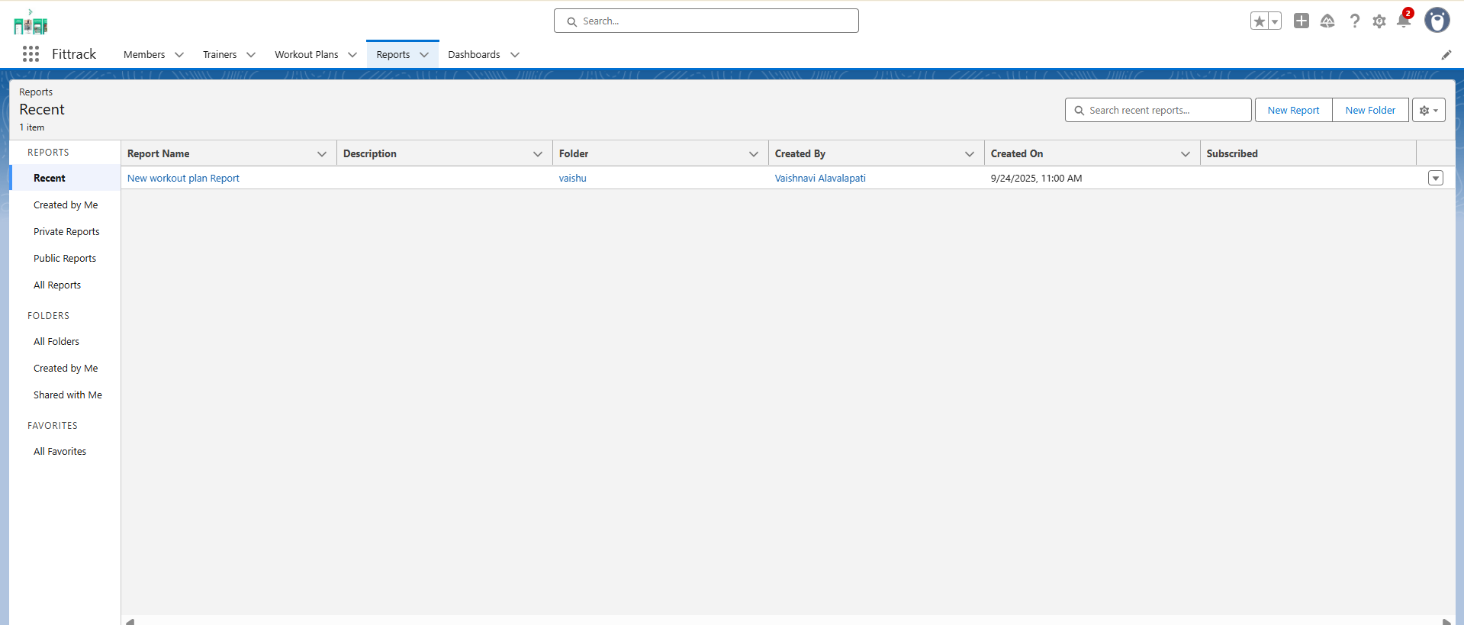
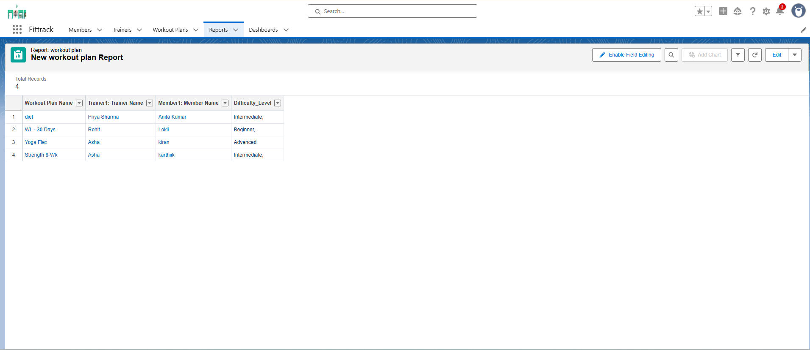
Dashboards:
- Donut chart – Active vs Expired Members
- Bar chart – Members per Trainer

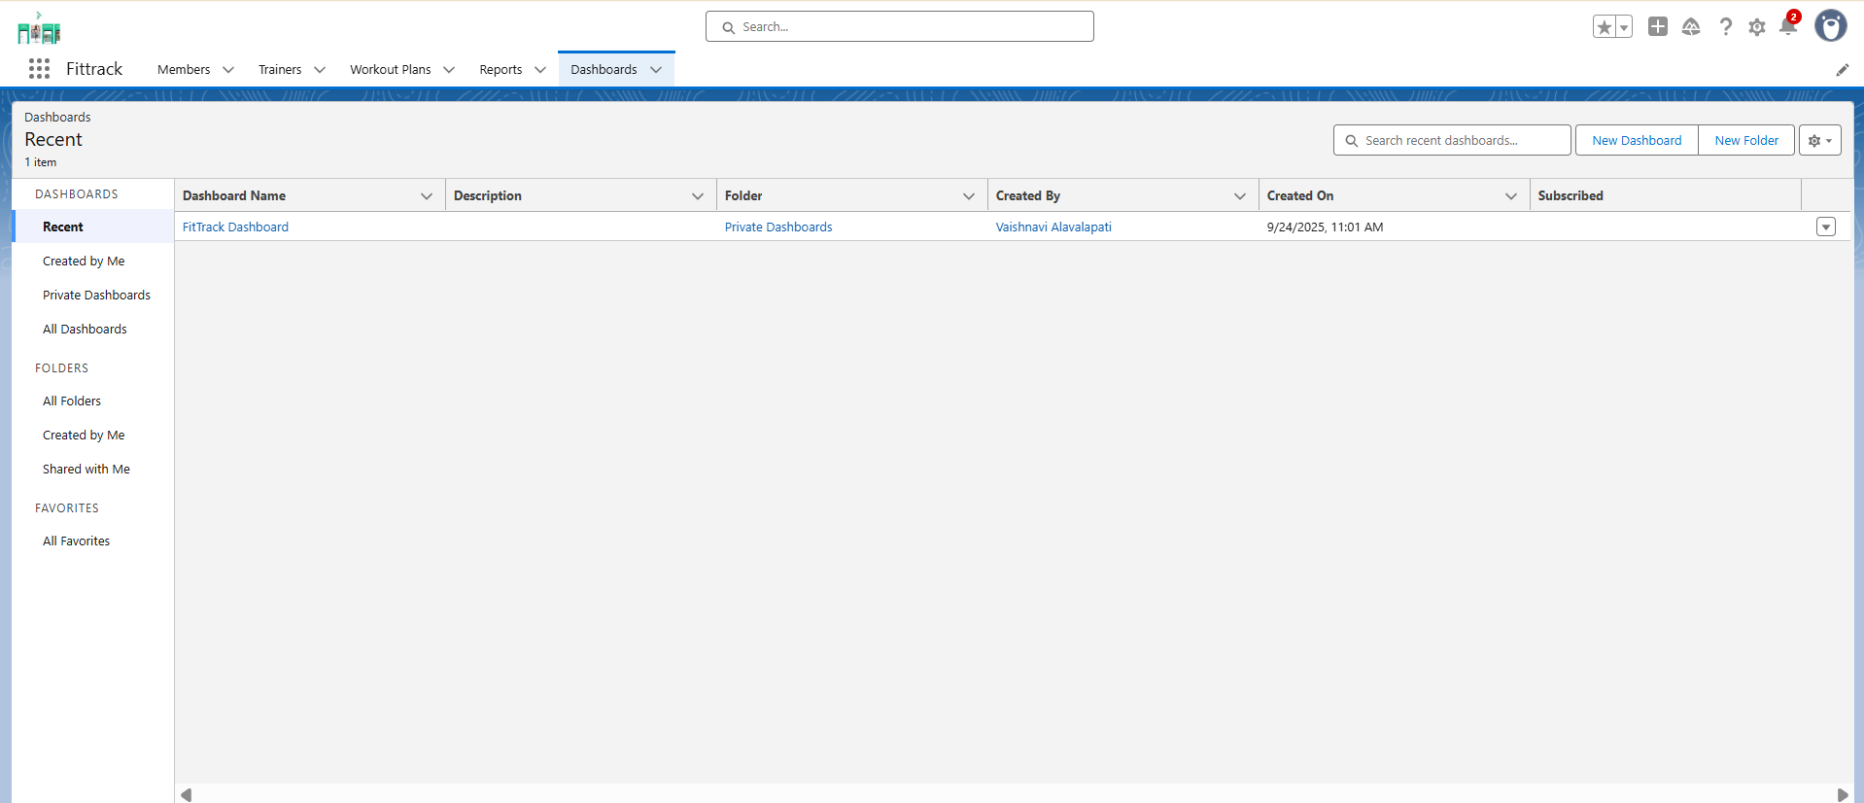

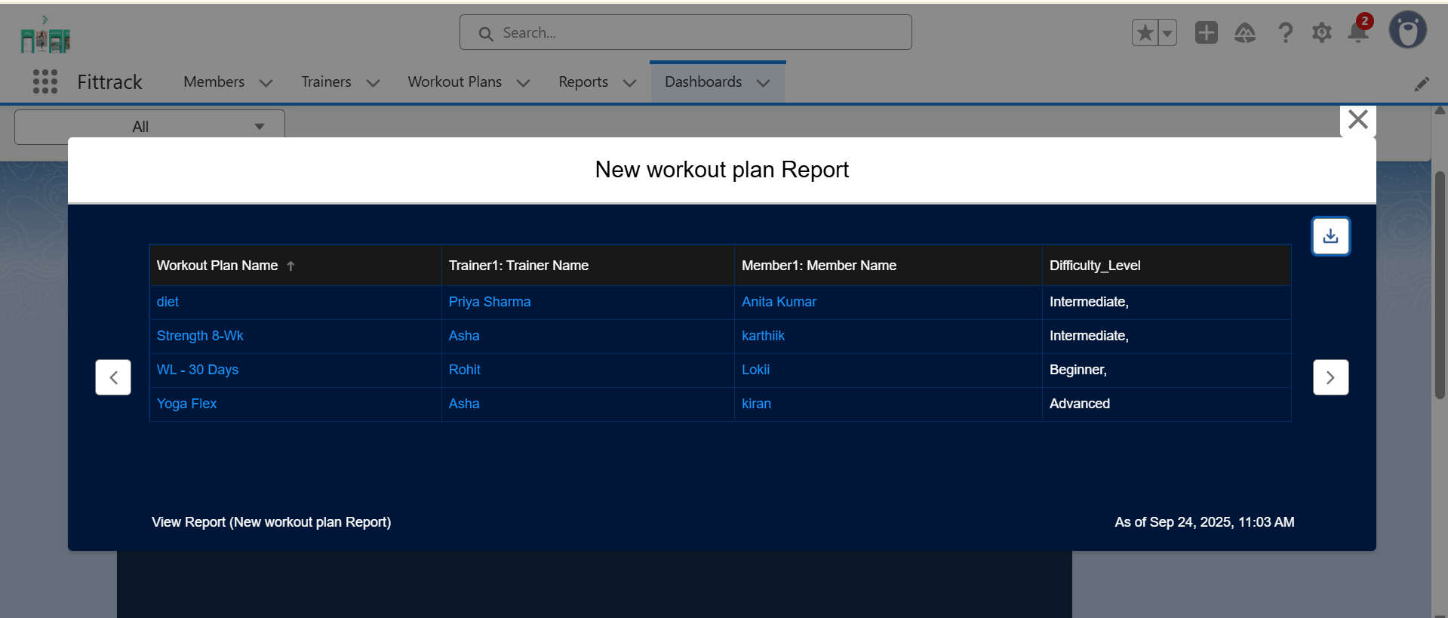

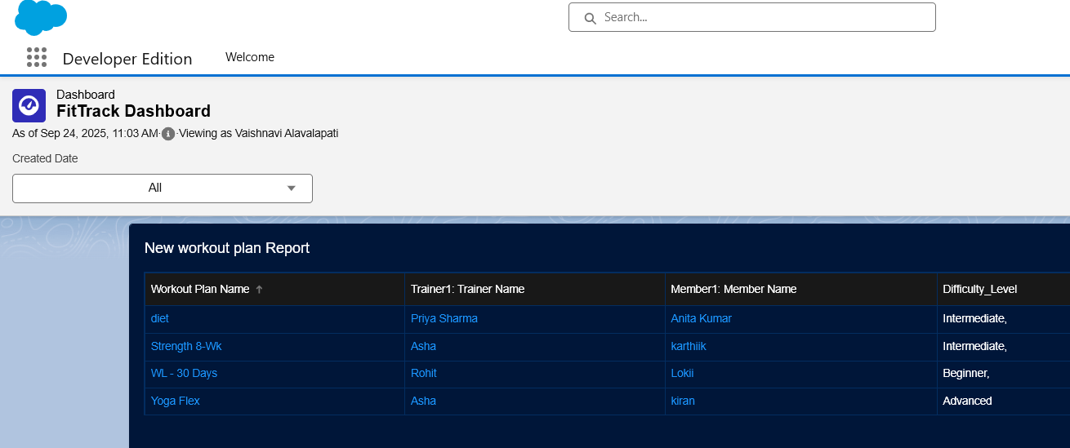
Security:
- Field-Level Security for sensitive data (Email, Phone)
- Sharing Rules applied
- Audit Trail for changes

Phase 10: Final Presentation & Demo Day
Purpose: Showcase the project.
- Pitch: Explain problem, solution, and FitTrack features
- Demo Walkthrough:
  - Create new member
  - Assign trainer
  - Create workout plan
  - Show dashboards (Active vs Expired Members, Trainer workload)
- Feedback Collection: From mentor or peers
- Handoff Documentation: Include project report, screenshots, and GitHub repo
- Portfolio Showcase: Add to LinkedIn or resume



